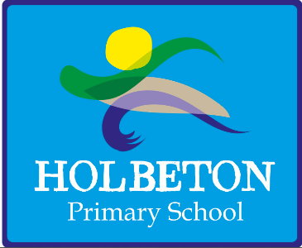
Holbeton Primary School
Required from 3 September 2018
Clerical Assistant Grade B Scp 7 – 11 (£8514 - £8778 actual)
Monday – Friday 08.30 – 1.00pm, 39 weeks per year

Holbeton Primary School is seeking to recruit a hard-working and enthusiastic Clerical Assistant to help us greet children, their parents and visitors to our small village school. Our beautiful and unique rural environment enables us to teach children lifelong skills, build lifelong memories and extend the happiness and magic of childhood for the whole time that they are with us and we would love you to help us do this.
You should be a cheerful and motivated individual who:
- Is able to work effectively as part of a small school team and provide efficient support to our children, parents and staff;
- Has the ability to multi-task and a flexible approach to the wide range of work involved, changing priorities and unpredictable demands;
- Is personable, professional and welcoming to all visitors, pupils, parents and staff;
- Has a friendly approach, is helpful and proactive and an excellent organiser.
As employers, we are committed to safeguarding and promoting the welfare of children. As part of our recruitment process successful applicants will be required to undertake an enhanced Disclosure and Barring Service (DBS) check and interviews will include questions about safeguarding children.
If you would like further details of these jobs, they can be found on our website at https://www.holbeton.devon.sch.uk/holbetonprimaryschool. Please request an application form from and send completed applications to head@holbeton.devon.sch.uk.
Closing date: Monday 9 July at noon with interviews being held later that week.
We very much look forward to receiving your application.

